**EX NO:6 E-TICKETING**

**USE CASE DIAGRAM:**

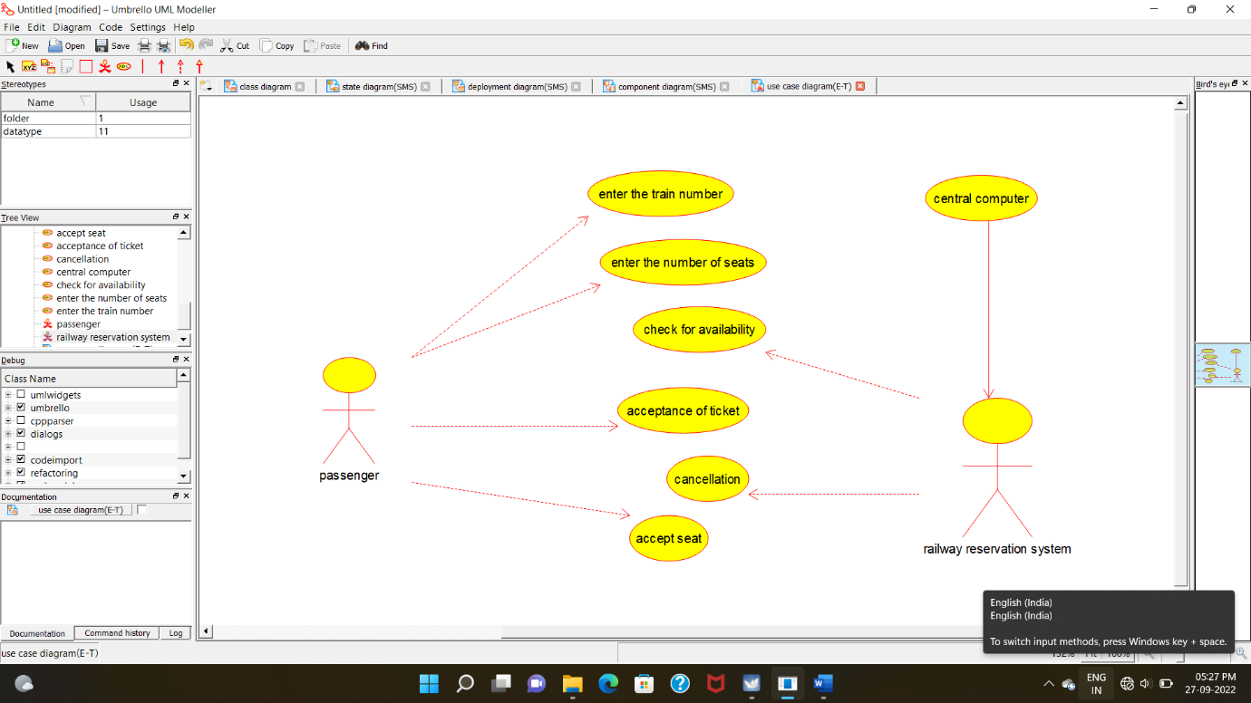

**CLASS DIAGRAM:**

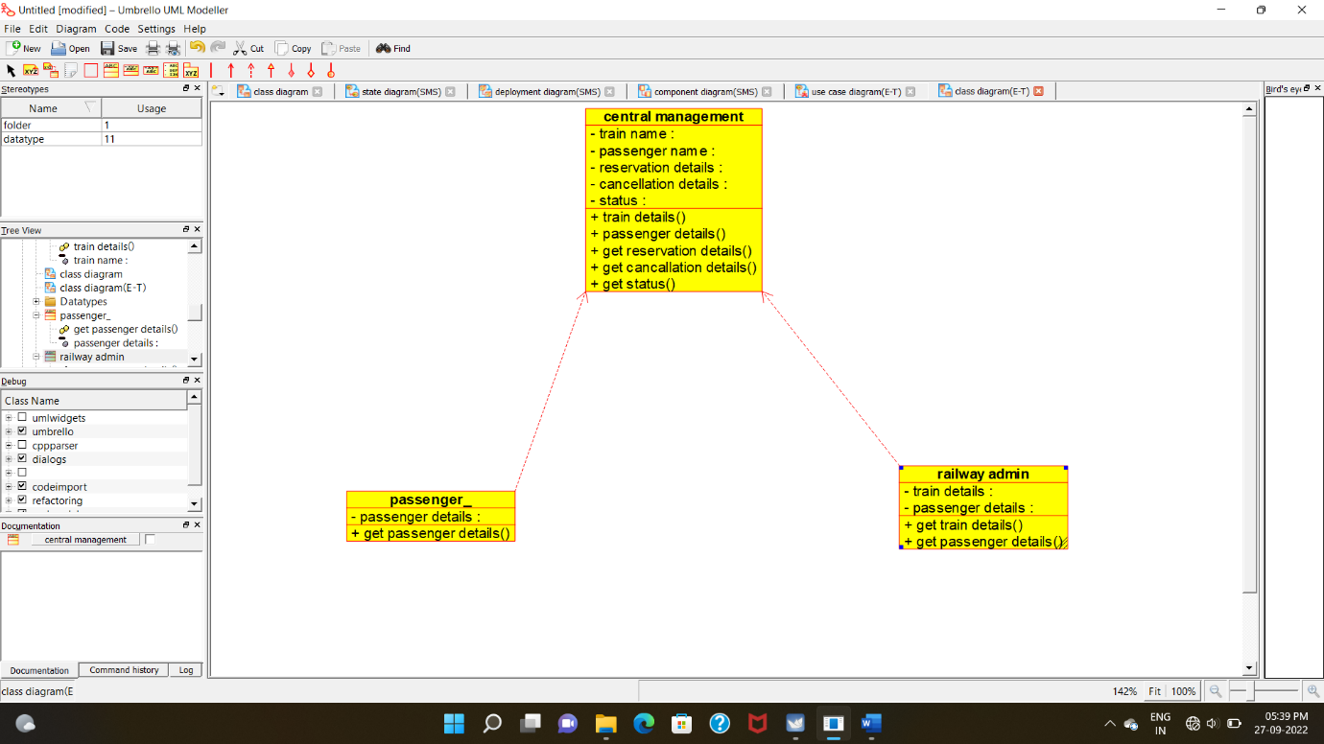

**ACTIVITY DIAGRAM**:

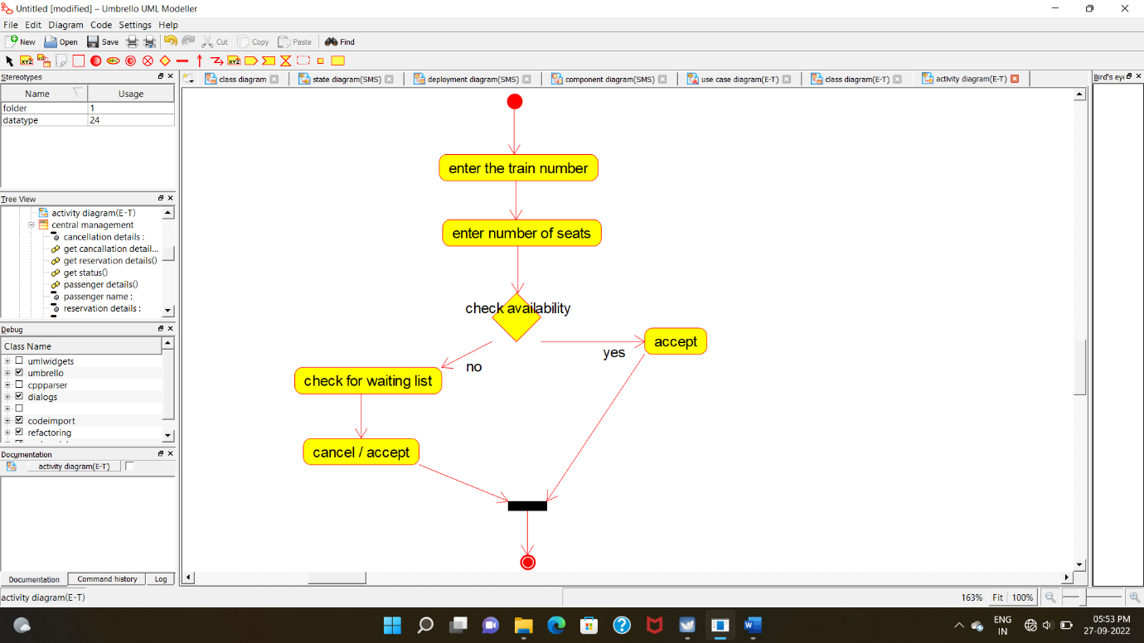

**SEQUENCE DIAGRAM**:

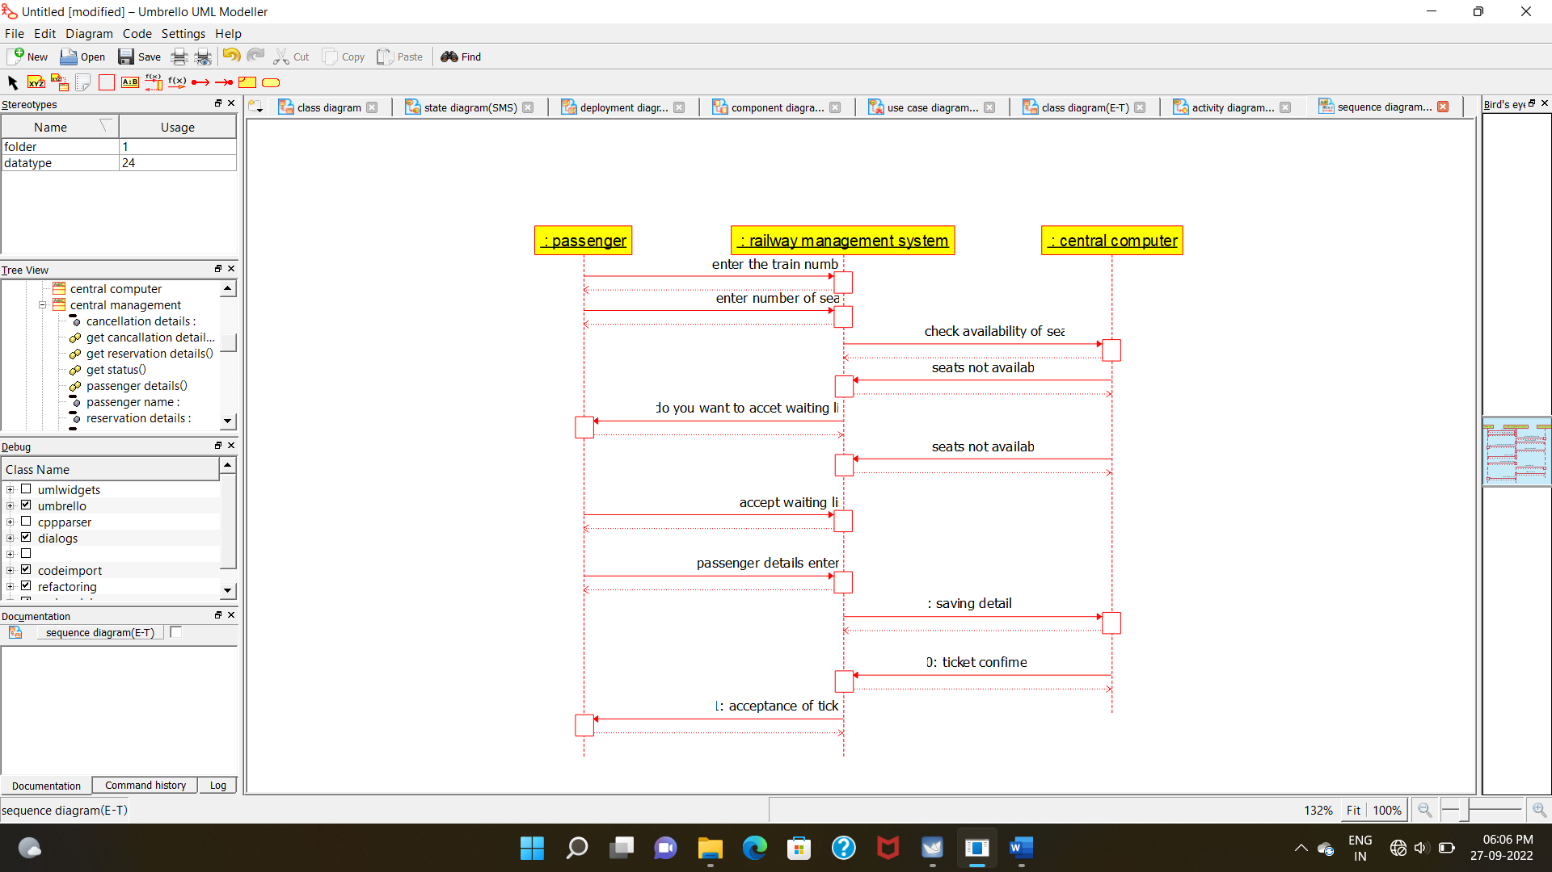

**COLLABORATION DIAGRAM:**

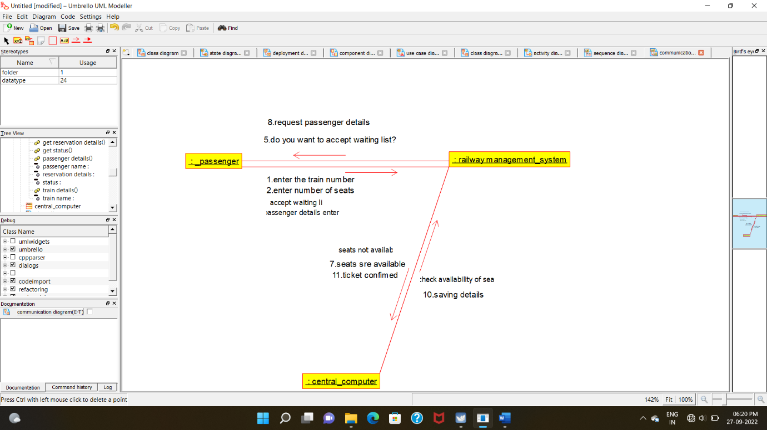

**STATE CHART DIAGRAM:**

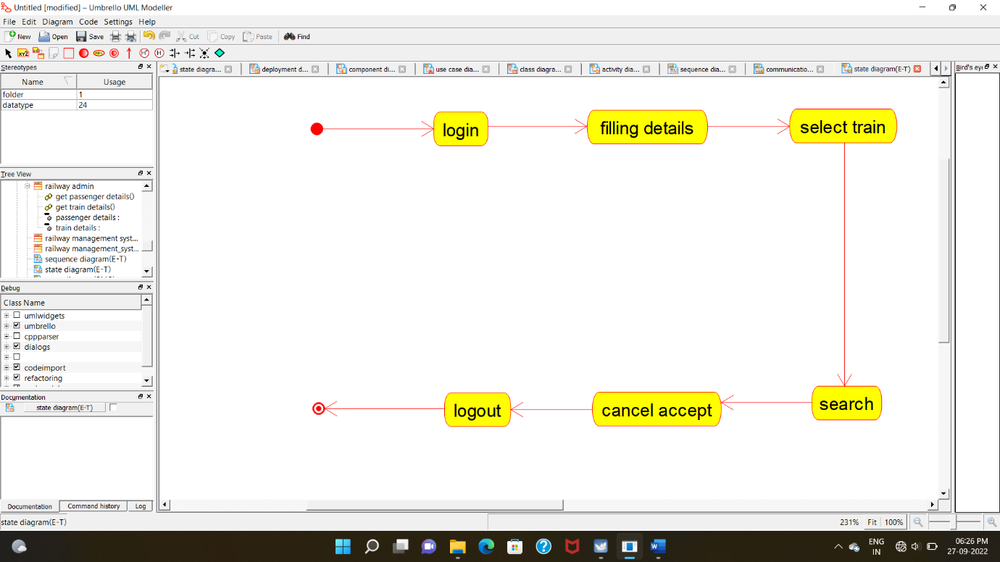

**COMPONENT DIAGRAM:**

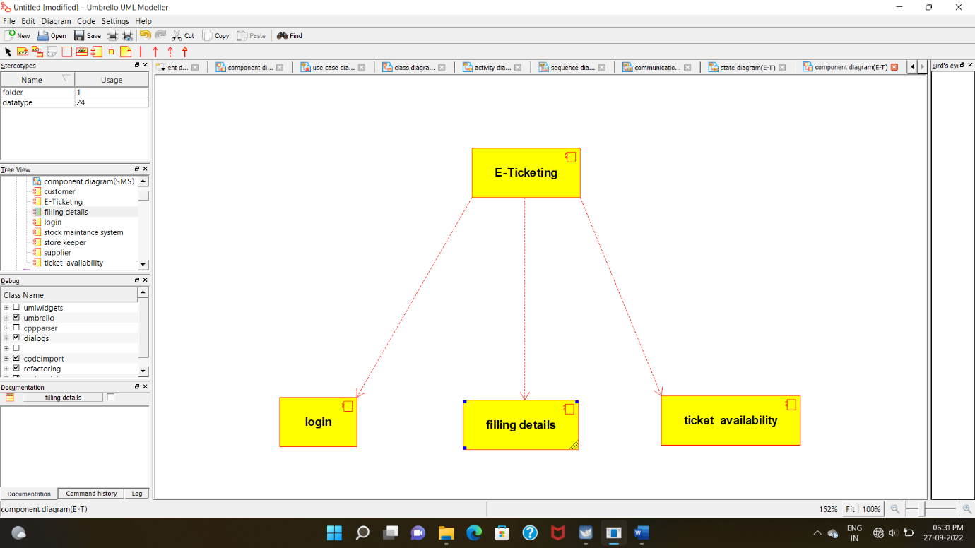

**DEPLOYMENT DIAGRAM:**

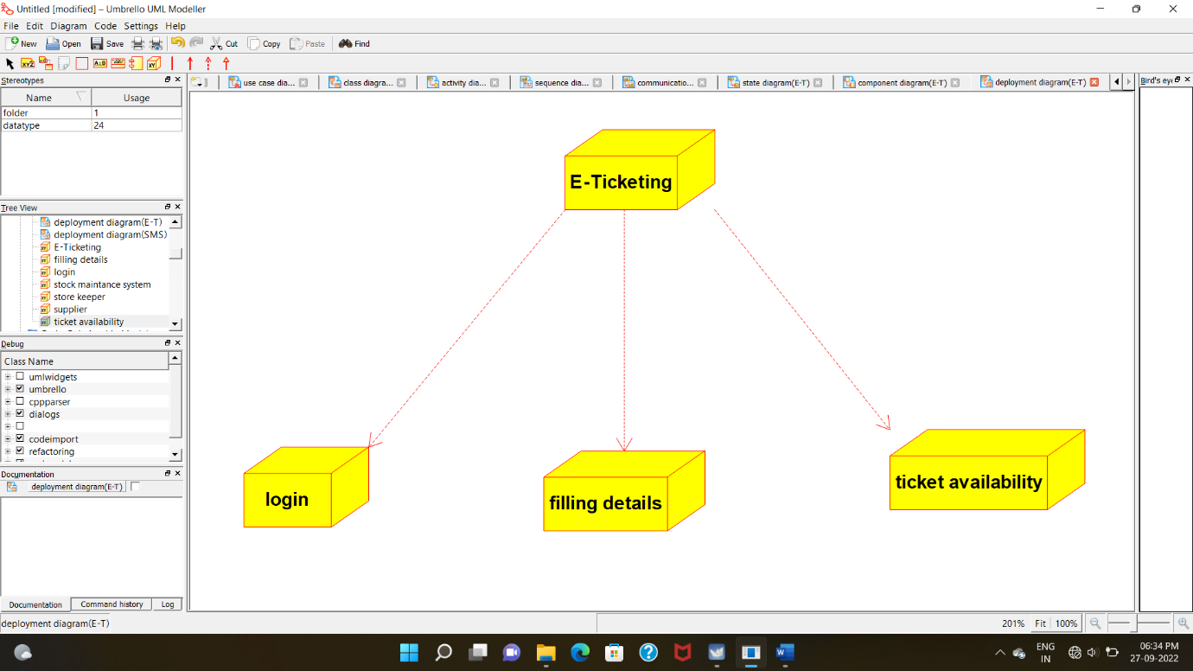

**PACKAGE DIAGRAM:**

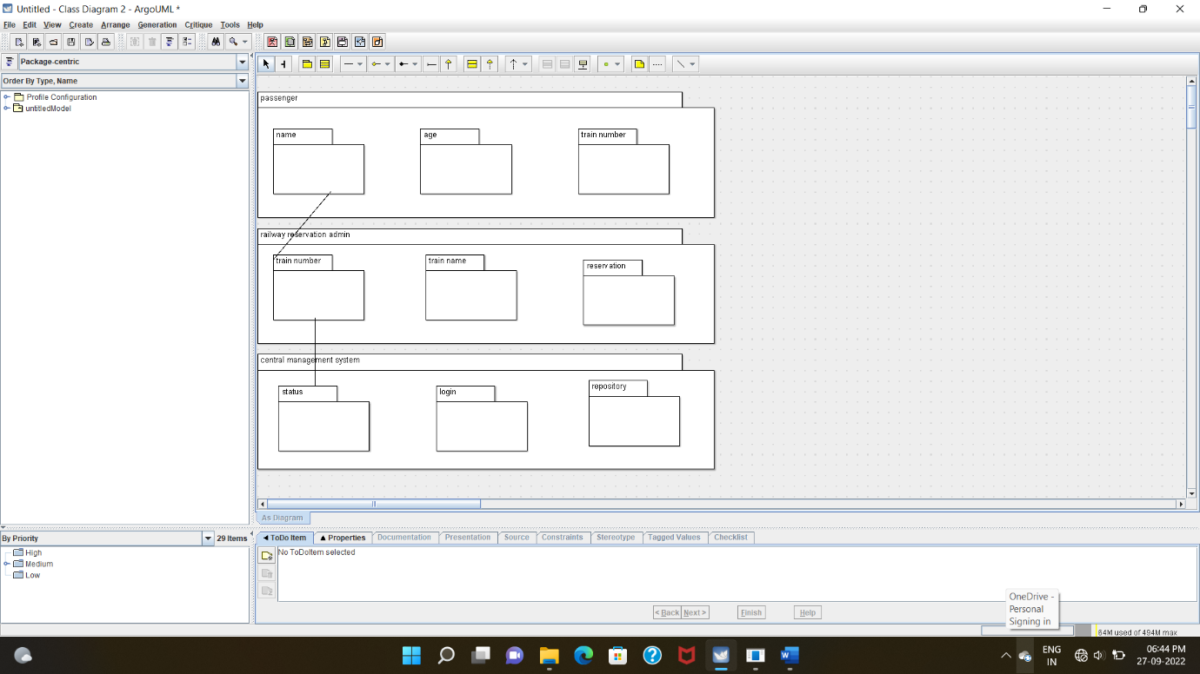

**PROGRAM CODING:**

**PASSENGER:**

/**

* Class passenger_

*/

public class passenger_ {

//

// Fields

//

private void passenger_details;

//

// Constructors

//

public passenger_ () { };

//

// Methods

//

//

// Accessor methods

//

/**

* Set the value of passenger_details

* @param newVar the new value of passenger_details

*/

private void setPassenger_details (void newVar) {

passenger_details = newVar;

}

/**

* Get the value of passenger_details

* @return the value of passenger_details

*/

private void getPassenger_details () {

return passenger_details;

}

//

// Other methods

//

/**

*/

public void get_passenger_details()

{

}

}

**CENTRAL MANAGEMENT SYSTEM:**

/**

* Class central_management

*/

public class central_management {

//

// Fields

//

private void train_name;

private void passenger_name;

private void reservation_details;

private void cancellation_details;

private void status;

//

// Constructors

//

public central_management () { };

//

// Methods

//

//

// Accessor methods

//

/**

* Set the value of train_name

* @param newVar the new value of train_name

*/

private void setTrain_name (void newVar) {

train_name = newVar;

}

/**

* Get the value of train_name

* @return the value of train_name

*/

private void getTrain_name () {

return train_name;

}

/**

* Set the value of passenger_name

* @param newVar the new value of passenger_name

*/

private void setPassenger_name (void newVar) {

passenger_name = newVar;

}

/**

* Get the value of passenger_name

* @return the value of passenger_name

*/

private void getPassenger_name () {

return passenger_name;

}

/**

* Set the value of reservation_details

* @param newVar the new value of reservation_details

*/

private void setReservation_details (void newVar) {

reservation_details = newVar;

}

/**

* Get the value of reservation_details

* @return the value of reservation_details

*/

private void getReservation_details () {

return reservation_details;

}

/**

* Set the value of cancellation_details

* @param newVar the new value of cancellation_details

*/

private void setCancellation_details (void newVar) {

cancellation_details = newVar;

}

/**

* Get the value of cancellation_details

* @return the value of cancellation_details

*/

private void getCancellation_details () {

return cancellation_details;

}

/**

* Set the value of status

* @param newVar the new value of status

*/

private void setStatus (void newVar) {

status = newVar;

}

/**

* Get the value of status

* @return the value of status

*/

private void getStatus () {

return status;

}

//

// Other methods

//

/**

*/

public void train_details()

{

}

/**

*/

public void passenger_details()

{

}

/**

*/

public void get_reservation_details()

{

}

/**

*/

public void get_cancallation_details()

{

}

/**

*/

public void get_status()

{

}

}

**RAILWAY ADMIN:**

/**

* Class railway_admin

*/

public class railway_admin {

//

// Fields

//

private void train_details;

private void passenger_details;

//

// Constructors

//

public railway_admin () { };

//

// Methods

//

//

// Accessor methods

//

/**

* Set the value of train_details

* @param newVar the new value of train_details

*/

private void setTrain_details (void newVar) {

train_details = newVar;

}

/**

* Get the value of train_details

* @return the value of train_details

*/

private void getTrain_details () {

return train_details;

}

/**

* Set the value of passenger_details

* @param newVar the new value of passenger_details

*/

private void setPassenger_details (void newVar) {

passenger_details = newVar;

}

/**

* Get the value of passenger_details

* @return the value of passenger_details

*/

private void getPassenger_details () {

return passenger_details;

}

//

// Other methods

//

/**

*/

public void get_train_details()

{

}

/**

*/

public void get_passenger_details()

{

}

}